

capstone project

Retail Analytics



Rahul SINGH MARKAM

Accio job

Data Analyst

Overview

The retail industry is a highly competitive and data-rich environment that offers vast opportunities for businesses to leverage insights for improved decision-making. This project focuses on performing an in-depth analysis of retail data, examining multiple dimensions such as sales, customer behavior, product performance, and regional preferences. The aim is to help retail businesses identify growth opportunities, optimize product offerings, and enhance customer satisfaction.

The project is structured into two primary phases. The first phase involves conducting exploratory data analysis (EDA) using SQL and Excel, where key questions are addressed by querying the available data. This data encompasses a range of variables such as customer demographics, product categories, sales trends, and payment information. The EDA process uncovers insights about customer purchasing patterns, regional performance, and product attributes that drive sales. The second phase involves developing a comprehensive Power BI dashboard, enabling interactive visualizations to track critical metrics and trends across different business dimensions.

Ultimately, this project is designed to empower decision-makers with data-driven insights that will help improve marketing strategies, increase average order values, optimize product portfolios, and penetrate untapped markets. By answering key business questions and visualizing trends, this retail analysis offers practical recommendations to boost revenue, enhance customer loyalty, and achieve long-term business growth.

Objective

The primary objectives of this retail analysis project are as follows:

* Identify Factors Contributing to Sales Performance: Examine the variables that drive sales in different regions and highlight the factors contributing to the highest revenue generation.
* Analyze Customer Purchasing Patterns: Explore how customer behavior influences purchasing decisions and identify strategies to increase average order value.
* Pinpoint Key Drivers of Sales Growth: Investigate the factors that contribute to increased sales and assess how they can be leveraged to achieve sustainable growth.
* Evaluate Product Features and Attributes: Determine which product features are most appealing to customers and assess their influence on sales performance.
* Optimize Product Mix: Identify gaps in the product portfolio and explore opportunities for optimizing the product mix to meet evolving market demands.
* Segment Underperforming Markets: Examine market segments where certain products are underperforming and suggest improvement strategies.
* Enhance Customer Loyalty and Retention: Identify factors that drive repeat purchases and customer loyalty, offering insights to improve retention.
* Tailor Marketing Strategies to Regional Preferences: Customize marketing efforts based on geographic preferences and demographic indicators to maximize regional sales.
* Target High-Value Customers for Acquisition: Analyze the characteristics of high-value customers and develop strategies for acquiring similar customer segments.
* Increase Market Penetration in Untapped Markets: Identify potential markets with low penetration and devise strategies to expand business in those areas.

Significance

The significance of this retail analysis project lies in its potential to transform raw data into actionable insights that can directly impact business performance. The retail landscape is highly dynamic, with consumer preferences and market conditions constantly evolving. As such, businesses must continuously adapt their strategies to stay competitive. This project offers several key contributions:

Data-Driven Decision Making: By providing clear, data-backed insights, the analysis helps businesses make more informed decisions about product management, customer engagement, and regional sales strategies.

Enhanced Customer Understanding: Through the exploration of customer behavior and preferences, the project enables businesses to tailor their marketing campaigns and product offerings to better meet customer needs.

Optimized Sales and Marketing Strategies: The project highlights areas where marketing efforts can be refined to increase reach and effectiveness, particularly in underperforming regions or market segments.

Improved Business Growth and Profitability: By identifying key drivers of sales growth and uncovering opportunities for revenue optimization, the analysis offers practical recommendations to boost profitability.

Comprehensive Business Overview: The Power BI dashboard provides an interactive platform for tracking business performance across multiple dimensions, making it easier for stakeholders to monitor key metrics and trends in real-time.

Data Dictionary

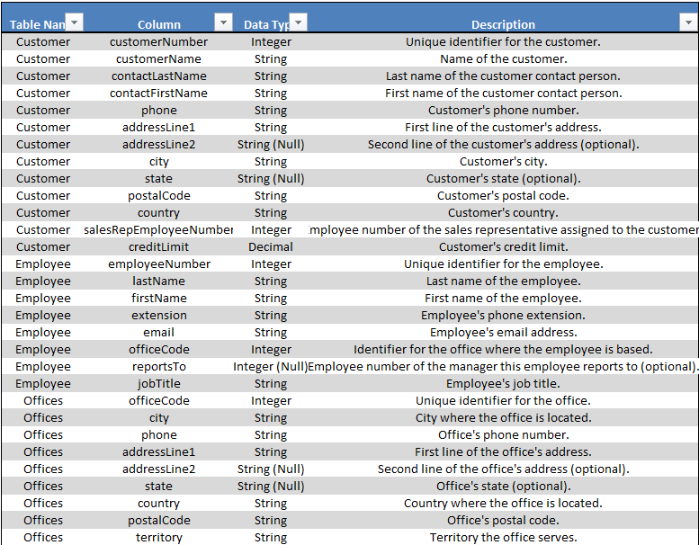

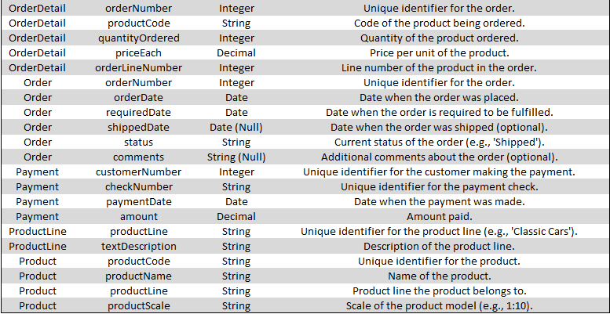

# Table Name: customers

Column Names: customerNumber, customerName, contactLastName, contactFirstName, phone, addressLine1, addressLine2, city, state, postalCode, country, salesRepEmployeeNumber, creditLimit

Description: Contains customer details including customer number, name, contact information, address, sales representative, and credit limit.

# Table Name: employees

Column Names: employeeNumber, lastName, firstName, extension, email, officeCode, reportsTo, jobTitle

Description: Details of employees such as employee number, name, contact details, office code, reporting manager, and job title.

# Table Name: offices

Column Names: officeCode, city, phone, addressLine1, addressLine2, state, country, postalCode, territory

Description: Information about office locations including office code, address, phone, country, and territory.

# Table Name: order_details

Column Names: orderNumber, productCode, quantityOrdered, priceEach, orderLineNumber

Description: Details of each order, including product code, quantity ordered, price per item, and order line number.

# Table Name: orders

Column Names: orderNumber, orderDate, requiredDate, shippedDate, status, comments

Description: Order-level information including order date, required date, shipped date, order status, and comments.

# Table Name: payments

Column Names: customerNumber, checkNumber, paymentDate, amount

Description: Customer payments, including customer number, check number, payment date, and payment amount.

# Table Name: product_lines

Column Names: productLine, textDescription

Description: Product line descriptions providing details about product categories.

# Table Name: products

Column Names: productCode, productName, productLine, productScale, productVendor, productDescription, quantityInStock, buyPrice, MSRP

Description: Product information such as product code, name, line, scale, vendor, description, quantity in stock, buying price, and MSRP.

**Note :**

This data dictionary outlines the structure of several key tables used in a retail analysis database, which provides comprehensive information on customers, employees, orders, products, payments, and offices. These tables, when combined, enable the tracking and analysis of sales, customer relationships, product inventory, and operational logistics.